

**Guide to the HMC Projects Online Application**

We are delighted that you are applying for a HMC Scholarship. Each candidate applies through a scholarship competition in his or her own country, organised by a HMC Country Coordinator. This document sets out information to help guide you through the online application for HMC Projects Central & Eastern Europe.

The application process begins on this link:

HMCP ONLINE APPLICATION PLATFORM

https://hmcprojects.schooladminonline.com/portal

All candidates have the obligation to pay administration fee in the amount of 75 KM. This fee is non-refundable. Payment instructions are here:

Bank account for Udruzenje PLUS

ASA Banka – account number 1340011130003225,

Please add the reference comment

**„**Uplata administrativne takse za HMC stipendiju**”**.

We would ask that the first six sections of this application (finishing with Personal Essay) are completed by you (the student), whilst the last two are completed alongside your parents.

**You can at any point 'Save & Finish Later', so it is not necessary to complete the application at one time. You can only submit your application once.**

Contents

Section 1: Country Questions 3

Section 2: Applicant Information 4

Section 3: Educational Information 5

Section 4: Language Skills 6

Section 5: Academic, Extracurricular and Personal Interests 7

Section 6: Personal Essay 9

Section 7: Household Information 10

Section 8: Candidate and Family Declaration 12

9. Review Screen 13

Checklist Items 14

# **Section 1: Country Questions**

You will then get a question about the type of scholarship you are applying for.

You are applying for academic year 2024/2025, year 12.

# **Section 2: Applicant Information**

The applicant’s religious belief would have no influence on the selection process.

# **Section 3: Educational Information**

**School Specialism** (vrsta programa obrazovanja) will give options of General, Classical, Science, Bilingual, Online, Other. **Type** will give options of Public or Private. If attending any other school(s) since age 11 it will ask for the name of the school, type and the year started and finished.

Enter X in State.

# **Section 4: Language Skills**

Though illustrated (above) for 1 language, you can enter up to 5 languages **additional to your own language**. Please start with English. The Common European Framework of Reference for Languages is [linked here](https://www.coe.int/en/web/common-european-framework-reference-languages/table-1-cefr-3.3-common-reference-levels-global-scale). You are also asked (see top of next page) whether you have transcript evidence for that level. If so, you upload that later as what is called a **checklist item**.

# **Section 5: Academic, Extracurricular and Personal Interests**

Please read HMC Projects “[Choosing subjects to study in the UK education system](https://s3.us-east-1.amazonaws.com/sa-assets-production/file_resources/68ccc80e-e395-11ed-bd92-02d365c396a3/8955efd9-2d24-11ee-bd92-02d365c396a3.pdf?1690534799)” when completing the section **above**. In the section **below**, note this is **academic** awards.

**You are then asked questions about sporting; performing and visual arts; clubs, organisations, or community service groups. The format is similar for each category and illustrated below for sport below. You can add up to 3 sports; 4 performing and visual arts; 4 clubs, organisations, or community service groups. Think about the priority activities in listing these.**

If you reply, ‘Yes’ to “Have you spent more than one month abroad?” it will ask where, when and how long.

You can add up to 4 weblinks to support your application. Consider your priorities.

**Note:** A later ‘checklist item’ will invite you to upload family photos.

# **Section 6: Personal Essay**

# **Section 7: Household Information**

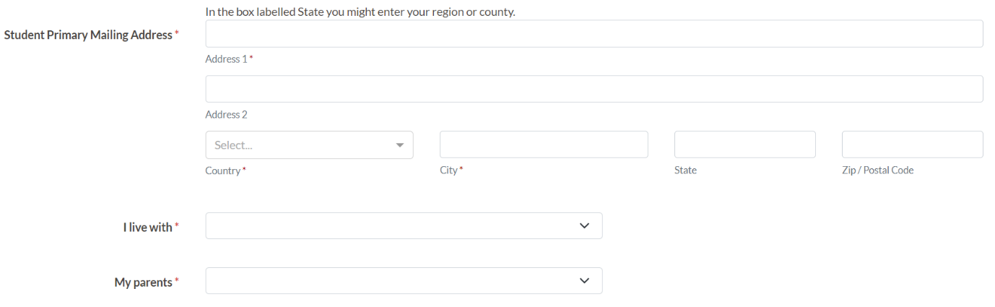

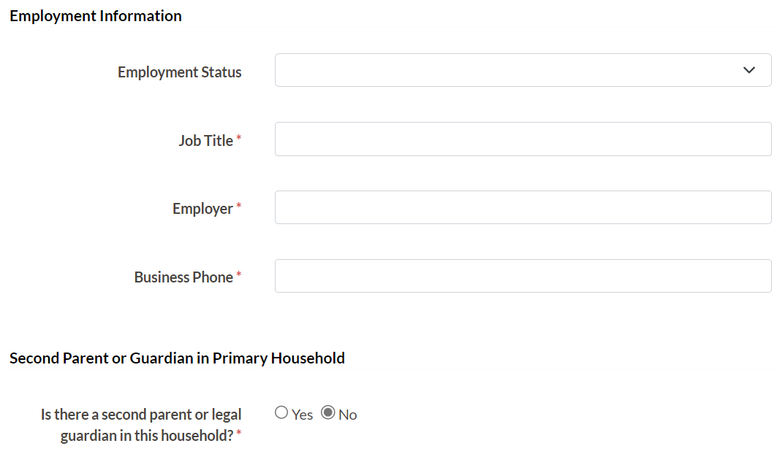

Note: Job Title, Employer and Business Phone will only be asked where the response is Employed or Self-Employed. If answering ‘Yes’ to second parent or legal guardian, it will repeat the previous questions. The same is true if there is an additional household with legal guardianship (see below).

For siblings it will request their name, relationship to you, age, current year in school (if that applies) and whether they have been scholars with HMC Projects.

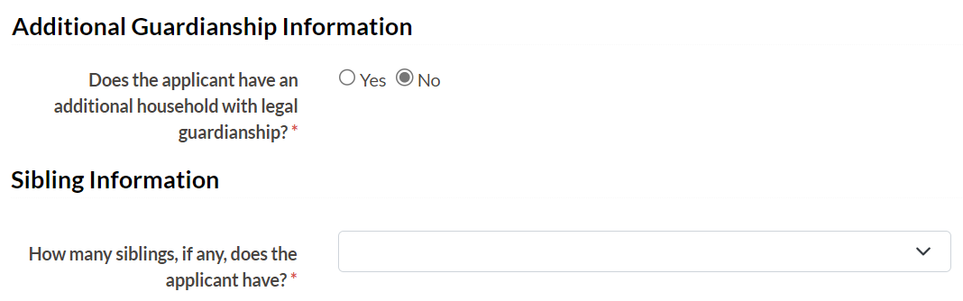

# **Section 8: Candidate and Family Declaration**

# **9. Review Screen**

Please read the whole application with care and amend if you need to. If you **Submit** (bottom of this Review page) you cannot make further changes.

After you **submit** your application, you will receive 2 confirmations:

1. The first is a visual confirmation that will appear on the screen after you submit your application.
2. The second is a later email thanking you for your application and asking you to visit your portal to view your candidate checklist items e.g. uploading your photos, school grades etc.

# **Checklist Items**

**After you have submitted your application form, you will be invited to return to the portal to submit what are called Checklist Items. These are:**

* **Applicant Photo**
* **Form Tutor (or School Principal), Maths and English Teacher Recommendations**
* **Grades**
* **Additional Supporting Evidence**
* **Parental Statement & Health Form**
* **HMC Projects Financial Declaration Form**

**You will also see listed the Spontaneous Essay Transcript Upload – this will be completed on your behalf by the Country Coordinator.**

**Applicant Photo** – a passport style photo

**Teacher Recommendation Forms** –Please use the online application system to contact the teacher. Completing the boxes will trigger an email from HMC Projects requesting they complete a form on your behalf. They submit this electronically. You will see when it is complete, but not the content of the recommendation.

**Grades** – you will be asked to download and complete a form with your grades on. In addition, please upload copies of the actual grade sheets from your school that match the information you entered on our document and uploaded.

Also, please use this section to upload any language certificates (e.g. IELTS) you referred to in the application form

**Additional Supporting Evidence** – include with your application recent digital photos of you, either by yourself or with your family or small group of friends at school, locally or on holiday. You might want this to reflect activities that matter to you, and you have mentioned in your application. Maximum number of 4 photos.

**Personal Statement & Health Form** – your parent(s) should complete this checklist item with you.

**HMC Projects Financial Declaration Form** - Please ask your parents to complete the online form.